# CS 255 System Design Document Template

## UML Diagrams

### UML Use Case Diagram

### UML Activity Diagrams

### 

### UML Sequence Diagram

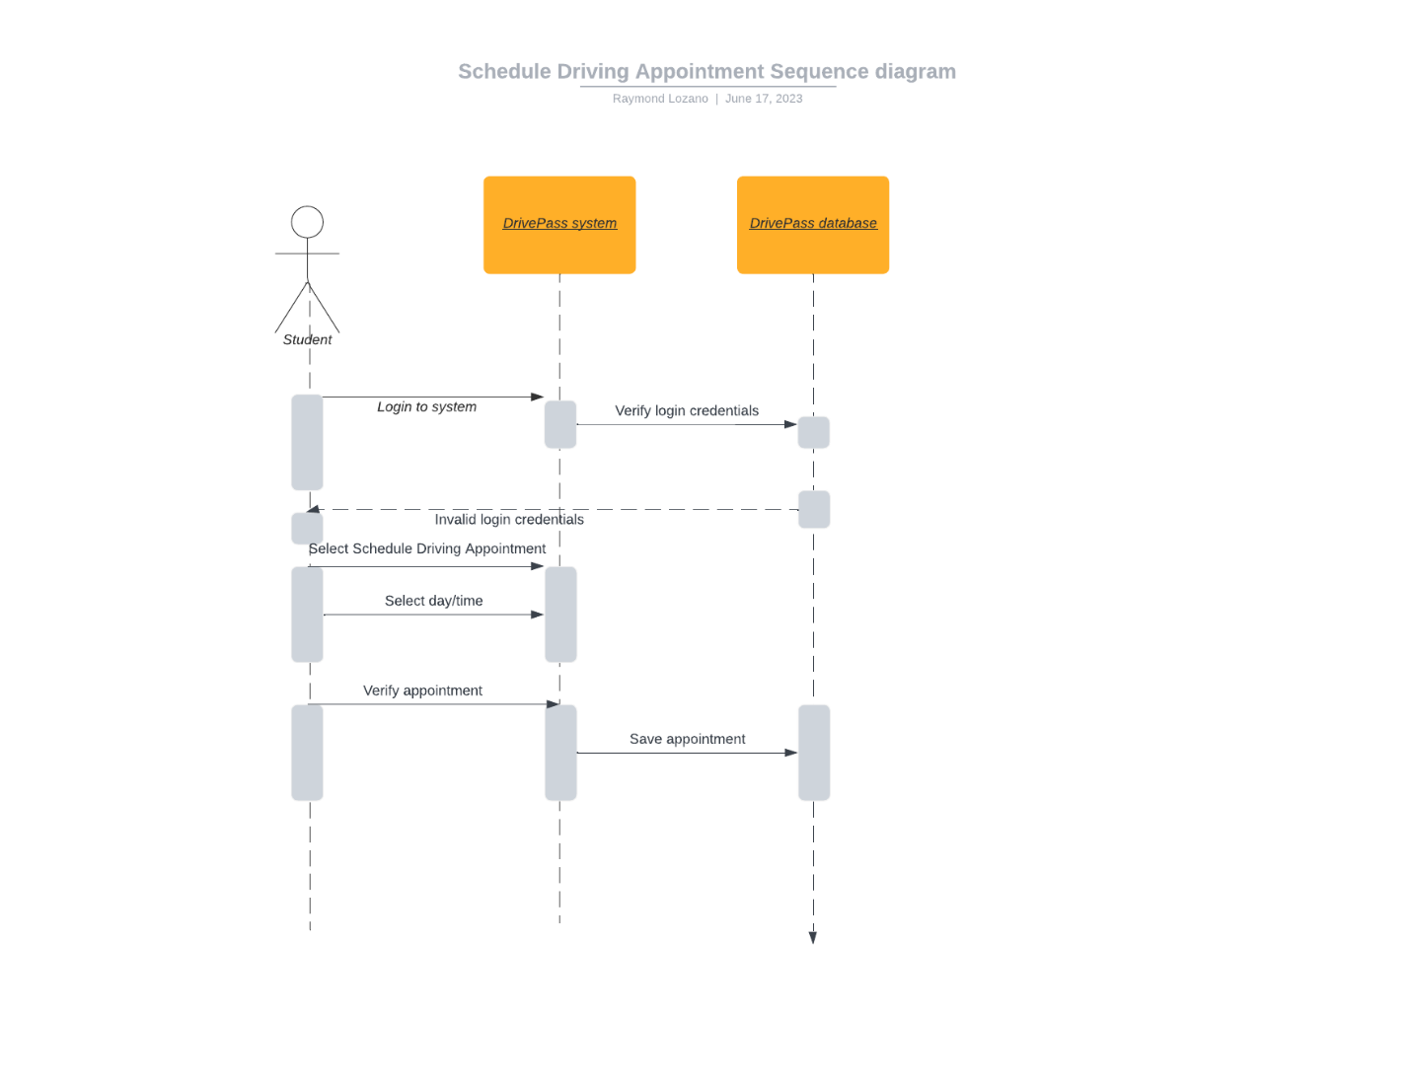

### UML Class Diagram

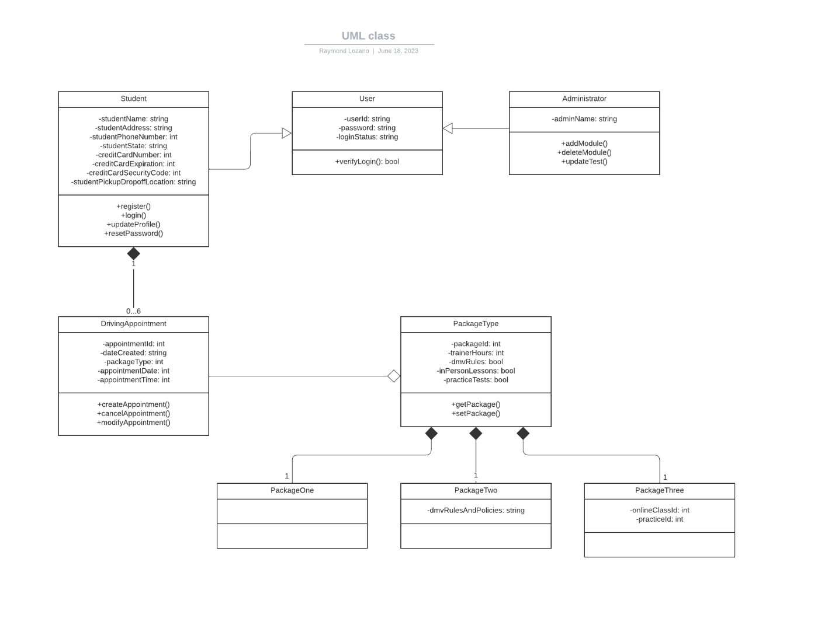

## Technical Requirements

Software requirements for hosting the system:

* Web-based, cloud-based system.
* Web Security will be handled by the chosen cloud-based system.
* Linux operating system preferred for cloud-based system.
* Compatibility across all operating systems.
* Compatibility across all web browsers.

Hardware requirements for hosting the system:

* One or more physical servers for handling large amounts of web traffic.
* Workstation (computer) powerful enough to handle running a virtual machine accessing the cloud-based system.
* Power source for the workstation.
* Working internet connection to access the cloud-based system when needed.
* Computer peripherals (mouse, keyboard, etc.).
* Any needed networking cables for equipment.

Software requirements for student/customer:

* Access to any web browser.
* Access to any operating system.

Hardware requirements for student/customer:

* Desktop, laptop, or mobile device such as a smartphone or tablet.
* Internet access.
* Power source.